-- 5. Develop queries to retrieve event information, generate attendee lists, and calculate event attendance statistics.

-- Get all events with details

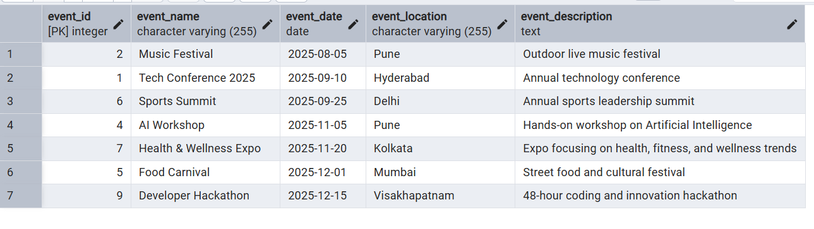

-- List of all attendees for events

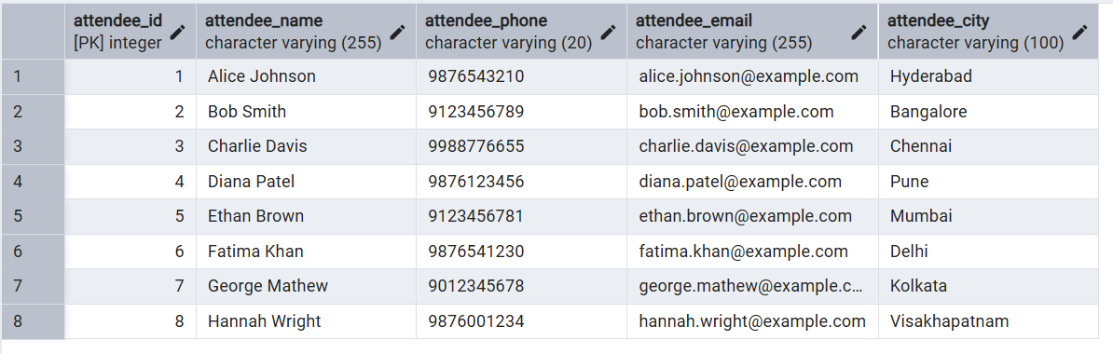

**calculate event attendance statistics.**

-- Count number of attendees for each event

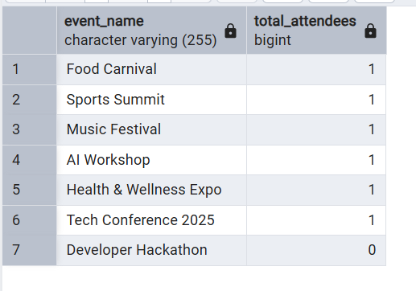

-- Total collected registration amount per event

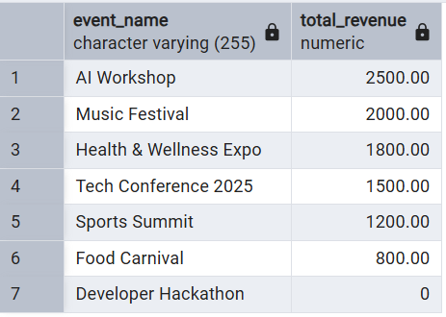

-- Find events that have no registrations yet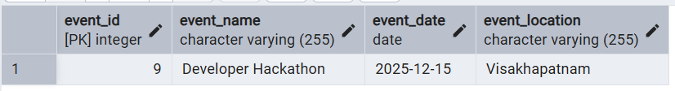

-- Number of events each attendee has registered for

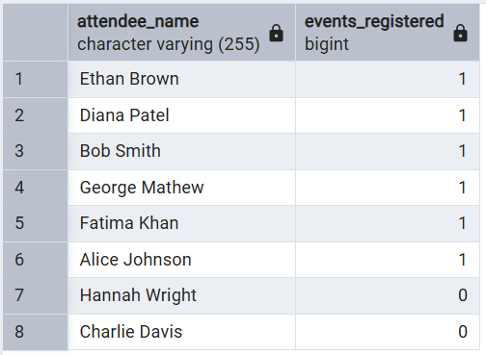

-- Breakdown of attendees by city

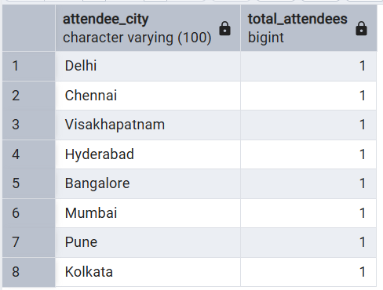

-- Most recent registrations DESC order

